|  |  |
| --- | --- |
| *Pacific Gas and Electric Company* | |
| Patch 7.6.5 Installation Guide | |
|  |  |
|  |  |
| Project | ED AM/GIS |
|  |  |
| Prepared by | Ashish Narasimham |
| Date | 9/11/2013 |
| Version | 1.0 |
| Version Type | Final |

|  |  |  |  |
| --- | --- | --- | --- |
| Revision History | | | |
| Document # | Date | Author | Summary of Changes |
| 1.0 | 9/11/13 | Ashish Narasimham | Initial Document Creation |

# Introduction

## Purpose

This document is intended to detail the implementation and configuration steps required to implement Patch 7.6.5 Installation Guide. This document describes the various configuration aspects required to complete any manual or automatic patch associated with this release. Each section in this document contains the steps required to patch the system in production.

## Terms Used

|  |  |
| --- | --- |
| OOTB | Out of the box. Unmodified from the commercial version. |
| TFS | Team Foundation Server |

## External Documents

Referenced are any external configuration documents or exports. These are documents that contain more detailed information about configuring a system or documents that can be loaded into an application to perform the configuration detailed in this document.

1. Connectivity Rules XML location:
   1. Location: \\sfetgis-nas01\sfgispoc_data\ApplicationDevelopment\IBM_Delivery\Production Release 5\Data Model Files\Connectivity
   2. Filename: ConnectivityRulesUpdated_Prod_rel_5.xml
2. SUBGenerator Personal Geodatabase:
   1. Location: \\sfetgis-nas01\sfgispoc_data\ApplicationDevelopment\IBM_Delivery\Production Release 5\Data Model Files
   2. Filename: SUBGenerator.mdb
3. Data Model Python Script
   1. Location: \\sfetgis-nas01\sfgispoc_data\ApplicationDevelopment\IBM_Delivery\Production Release 5\Data Model Files
   2. Filename: 01_AddCustomerOwnedIndicator_To_Substation_Tables.py

# List of Fixes

Below is the list of change requests detailing all fixes for the data model for this release:

|  |  |  |  |
| --- | --- | --- | --- |
| **Item Number** | | **Title** | **Work Item Type** |
| [9858](http://edappgistfsprd1:8080/tfs/ElectricDistCollection/EDAMGIS/_workItems#_a=edit&newQuery=true&id=9858) | | Data Model 7.6.5 | Change Request |
| [9365](http://edappgistfsprd1:8080/tfs/ElectricDistCollection/EDAMGIS/_workItems#_a=edit&newQuery=true&id=9365) | Add New Value to Data Conversion Supplier Domain | Change Request |
| [9886](http://edappgistfsprd1:8080/tfs/ElectricDistCollection/EDAMGIS/_workItems#_a=edit&newQuery=true&id=9886) | Change Description Value for Switch Attachment Type Domain | Change Request |
| [9708](http://edappgistfsprd1:8080/tfs/ElectricDistCollection/EDAMGIS/_workItems#_a=edit&newQuery=true&id=9708) | Change Multiple Anno Feature Classes' Subclass Properties | Change Request |
| [9869](http://edappgistfsprd1:8080/tfs/ElectricDistCollection/EDAMGIS/_workItems#_a=edit&newQuery=true&id=9869) | Create Indexes on SUBElectricStitchPoint | Change Request |
| [9660](http://edappgistfsprd1:8080/tfs/ElectricDistCollection/EDAMGIS/_workItems#_a=edit&newQuery=true&id=9660) | Create New Annotation Feature Class SUBGeneratorAnno | Change Request |
| [9658](http://edappgistfsprd1:8080/tfs/ElectricDistCollection/EDAMGIS/_workItems#_a=edit&newQuery=true&id=9658) | Create New Domain SUB Gen PrimeMover | Change Request |
| [9657](http://edappgistfsprd1:8080/tfs/ElectricDistCollection/EDAMGIS/_workItems#_a=edit&newQuery=true&id=9657) | Create New Feature Class SUBGenerator | Change Request |
| [9652](http://edappgistfsprd1:8080/tfs/ElectricDistCollection/EDAMGIS/_workItems#_a=edit&newQuery=true&id=9652) | Multiple PARs: Add Values To SUB Interrupting Current Rating | Change Request |
| [9653](http://edappgistfsprd1:8080/tfs/ElectricDistCollection/EDAMGIS/_workItems#_a=edit&newQuery=true&id=9653) | PAR 25821: Add Value To SUB Transformer Cooling Class | Change Request |
| [9655](http://edappgistfsprd1:8080/tfs/ElectricDistCollection/EDAMGIS/_workItems#_a=edit&newQuery=true&id=9655) | PAR 26947: Add Value To SUB Boost/Buck Percent | Change Request |
| [9661](http://edappgistfsprd1:8080/tfs/ElectricDistCollection/EDAMGIS/_workItems#_a=edit&newQuery=true&id=9661) | PAR 27206: Create Field CustomerOwnedIdc on Feature Classes | Change Request |
| [9781](http://edappgistfsprd1:8080/tfs/ElectricDistCollection/EDAMGIS/_workItems#_a=edit&newQuery=true&id=9781) | PAR#27700: Add Value To SUB Rated Amps Domain | Change Request |
| [9929](http://edappgistfsprd1:8080/tfs/ElectricDistCollection/EDAMGIS/_workItems#_a=edit&newQuery=true&id=9929) | Add Additional Connectivity Rules | Change Request |

## Summary of Steps to Complete Patch

These are the high-level steps to complete the installation and configuration of the data model patch. Use this table as a guide for completing the installation. Links are provided that can lead either within the document for detailed explanations or to external sites such as Sharepoint.

|  |  |  |  |
| --- | --- | --- | --- |
|  | **Step Name** | **Description** | **CR (if applicable)** |
|  | Open a Database Connection | Open a database connection in ArcCatalog | - |
|  | Add New Value to Data Conversion Supplier Domain | Add a value to the domain | [9365](http://edappgistfsprd1:8080/tfs/ElectricDistCollection/EDAMGIS/_workItems#_a=edit&newQuery=true&id=9365) |
|  | Change Description Value for Switch Attachment Type Domain | Change coded value description for a code/value pair in Switch Attachment Type | [9886](http://edappgistfsprd1:8080/tfs/ElectricDistCollection/EDAMGIS/_workItems#_a=edit&newQuery=true&id=9886) |
|  | Create Indexes on SUBElectricStitchPoint | Create indexes on the SUBElectricStitchPoint table to make queries on the object class faster | [9869](http://edappgistfsprd1:8080/tfs/ElectricDistCollection/EDAMGIS/_workItems#_a=edit&newQuery=true&id=9869) |
|  | Create New Domain SUB Gen PrimeMover | Create new domain titled SUB Gen PrimeMover | [9658](http://edappgistfsprd1:8080/tfs/ElectricDistCollection/EDAMGIS/_workItems#_a=edit&newQuery=true&id=9658) |
|  | Create New Feature Class SUBGenerator/SUBGeneratorAnno | Create new SUBGenerator feature class | [9657](http://edappgistfsprd1:8080/tfs/ElectricDistCollection/EDAMGIS/_workItems#_a=edit&newQuery=true&id=9657), [9660](http://edappgistfsprd1:8080/tfs/ElectricDistCollection/EDAMGIS/_workItems#_a=edit&newQuery=true&id=9660) |
|  | Multiple PARs: Add Values To SUB Interrupting Current Rating | Add multiple values to the SUB Interrupting Current Rating domain | [9652](http://edappgistfsprd1:8080/tfs/ElectricDistCollection/EDAMGIS/_workItems#_a=edit&newQuery=true&id=9652) |
|  | PAR 25821: Add Value To SUB Transformer Cooling Class | Add a value to the SUB Transformer Cooling Class domain | [9653](http://edappgistfsprd1:8080/tfs/ElectricDistCollection/EDAMGIS/_workItems#_a=edit&newQuery=true&id=9653) |
|  | PAR 26947: Add Value To SUB Boost/Buck Percent | Add a value to the SUB Boost/Buck Percent domain | [9655](http://edappgistfsprd1:8080/tfs/ElectricDistCollection/EDAMGIS/_workItems#_a=edit&newQuery=true&id=9655) |
|  | PAR 27206: Create Field CustomerOwnedIdc on Feature Classes | Create the CustomerOwnedIDC field on SubstationDataset feature classes | [9661](http://edappgistfsprd1:8080/tfs/ElectricDistCollection/EDAMGIS/_workItems#_a=edit&newQuery=true&id=9661) |
|  | PAR#27700: Add Value To SUB Rated Amps Domain | Add a value to the SUB Rated Amps domain | [9781](http://edappgistfsprd1:8080/tfs/ElectricDistCollection/EDAMGIS/_workItems#_a=edit&newQuery=true&id=9781) |
|  | Add Additional Connectivity Rules | Import connectivity rules XML into the database | [9929](http://edappgistfsprd1:8080/tfs/ElectricDistCollection/EDAMGIS/_workItems#_a=edit&newQuery=true&id=9929) |
|  | Update Data Model Version Table | Update the data model version table to reflect this update | - |

# Open a Database Connection in ArcCatalog

1. Open ArcCatalog.
2. Within the Catalog Tree, expand “Database Connections” and open the active connection for this process. This is the connection that is referenced in the change request associated with this document (EDGIS<DB name in the format X#Y> )

# Add New Value to Data Conversion Supplier Domain

1. Right click on the SDE connection and select ‘Properties’ to bring up window with the Domains tab  
   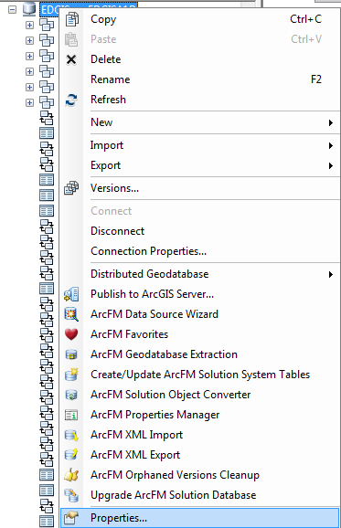
2. Navigate to the Domains tab and find the Data Conversion Supplier Domain.   
   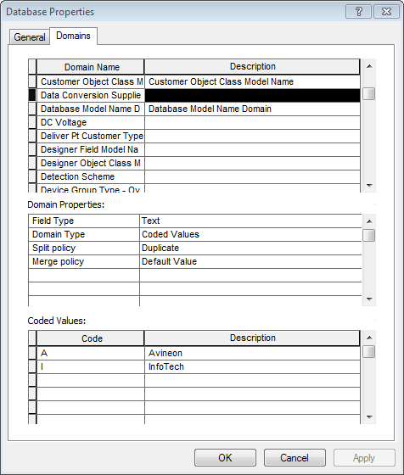
3. Add the value S/Schematics into the domain, resulting in the following screen:  
   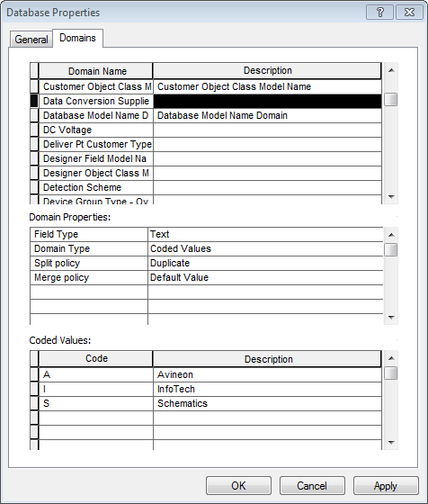
4. Select Apply to save the changes.

# Change Description Value for Switch Attachment Type Domain

1. In the same Domains tab of the previous step, navigate to the Switch Attachment Type domain  
   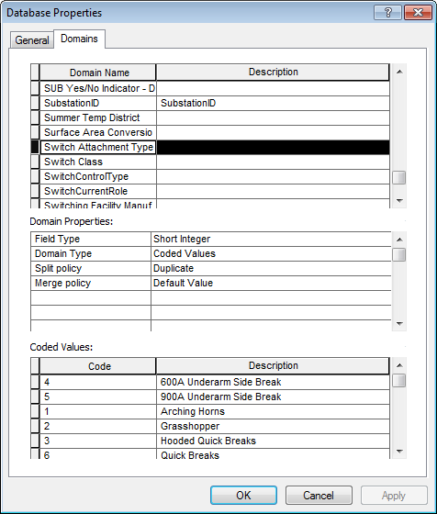
2. Locate the 1/Arching Horns code/value.  
   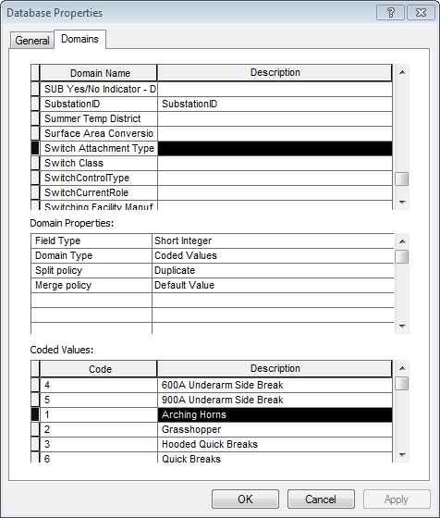
3. Change the description to ‘Arcing Horns’ to match the following screen:  
   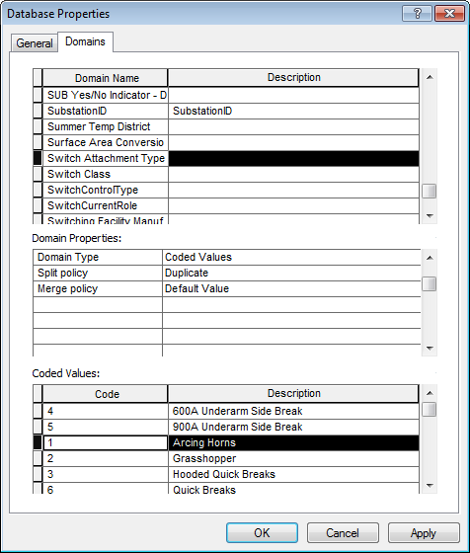
4. Click Apply to save changes.

# Create Indexes on SUBElectricStitchPoint

1. Navigate SUBElectricStichPoint under the SubstationDataset, right click, and select Properties.
2. Select the Indexes tab.  
   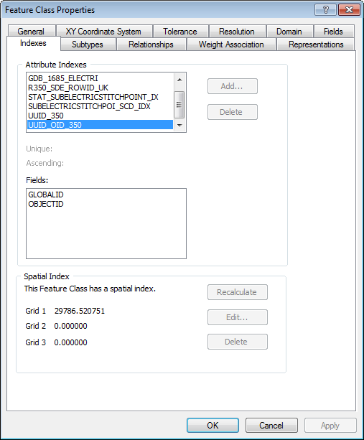
3. Select the ‘Add…’ button.  
   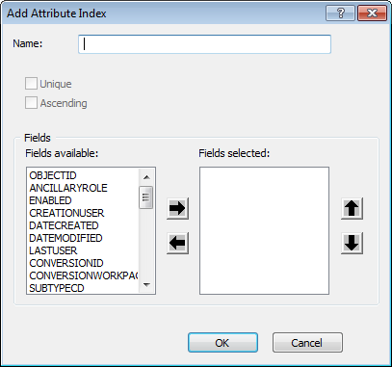
4. Type in the name: ‘SUBELECSTITCHPT_SUBID_IDX’.
5. Select the SUBSTATIONID and click the arrow pointing right to move it to the selected fields area:  
   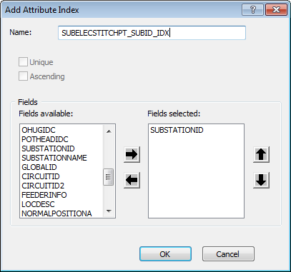
6. Select OK to finish the index creation.
7. Select ‘Add…’ again to add the second index
8. Type in the name: ‘SUBELECSTITCHPT_SUBNAME_IDX’
9. Select SUBSTATIONNAME from the available fields and click the arrow pointing right to add it to the selected fields:  
   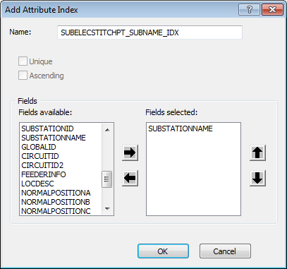
10. Select OK to add the index and OK again to save changes.

# Create New Domain SUB Gen PrimeMover

1. Right click the SDE connection and click Properties.  
   
2. In the Domains tab, scroll to the bottom of the Domains list. You should see a blank row:  
   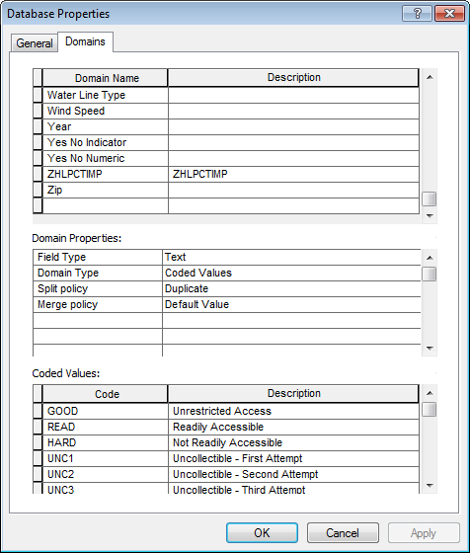
3. Select the empty cell in the Domain Name column to create a new domain.
   1. Type in ‘SUB Gen PrimeMover’ for the Domain Name and leave the description blank.
   2. Set the Field Type to Text
   3. Set the Domain Type to Coded Values
   4. Set the Split Policy to Default Value
   5. Set the Merge Policy to Default Value
   6. In the bottom ‘Coded Values:’ window, input the following codes/values:
      1. HYD/Hydro
      2. SOL/Solar
      3. BIO/Biofuel
      4. NUC/Nuclear
4. Your end product should look like this:  
   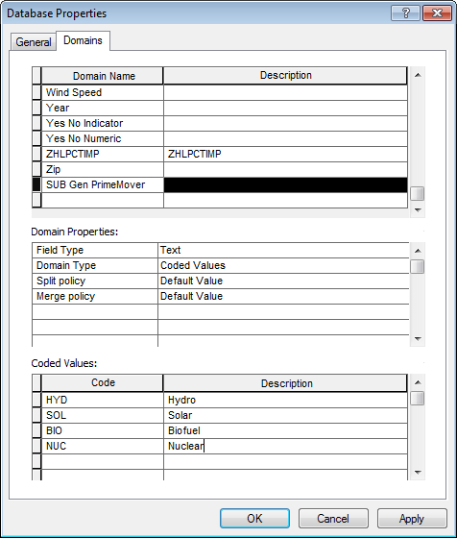
5. Select OK to save changes.

# Multiple PARs: Add Values To SUB Interrupting Current Rating

1. Right click the SDE connection and select Properties.  
   
2. In the Domains tab, navigate to the ‘SUB Interrupting Current Rating’ domain and in the Coded Values list, scroll to the bottom. You will see an empty row.  
   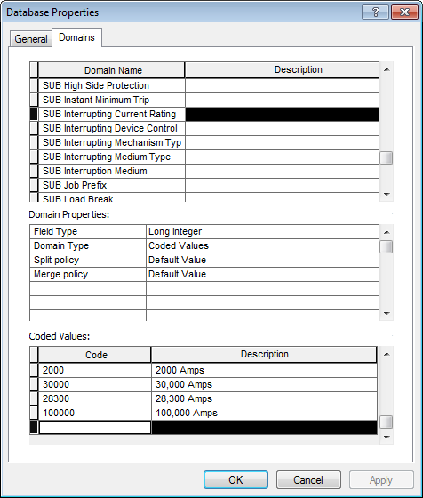
3. Type in the following four codes/descriptions one by one, pressing enter after each one to finish the creation of the row:
   1. 125000/125,000 Amps
   2. 21000/21,000 Amps
   3. 29000/29,000 Amps
   4. 26000/26,000 Amps
4. After you have finished, you will see the following end result:  
   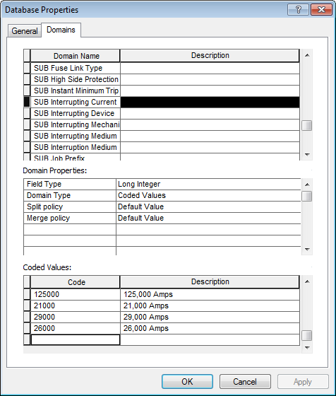
5. Select OK to save changes.

# PAR 25821: Add Value To SUB Transformer Cooling Class

1. Right click the SDE connection and select Properties.  
   
2. In the Domains tab, navigate to the SUB Transformer Cooling Class domain and scroll to the bottom. There should be an empty row at the bottom.  
   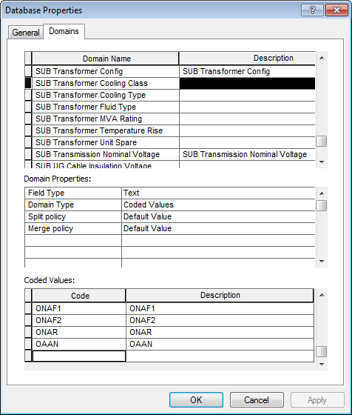
3. Select the Code column in the empty row and add the following value: SC/SC. Your screen should look like the following after the change is complete:  
   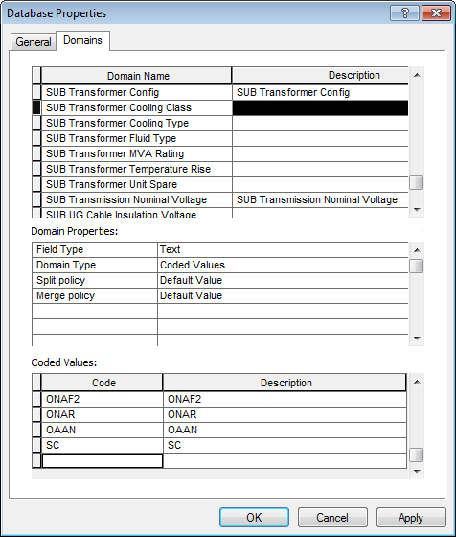
4. Select OK to save changes.

# PAR 26947: Add Value To SUB Boost/Buck Percent

1. Right click the SDE connection and select Properties.  
   
2. In the Domains tab, navigate to the SUB Boost/Buck Percent domain and scroll to the bottom. There should be an empty row at the bottom.  
   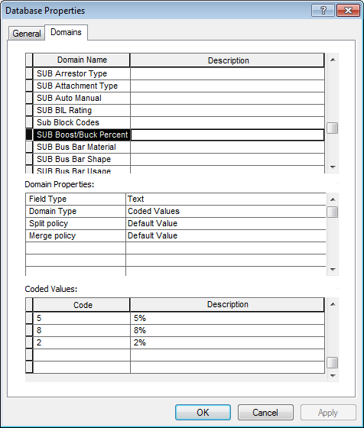
3. Select the Code column in the empty row and add the following value: 9.85/9.85%. Your screen should look like the following after the change is complete:

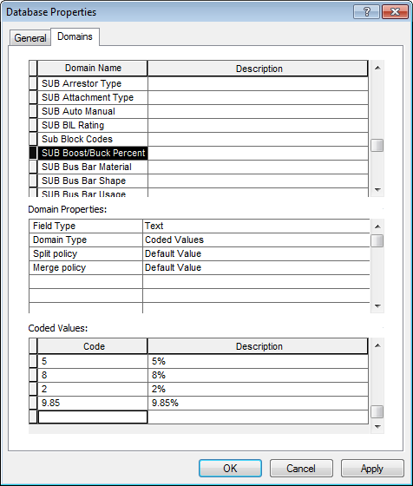

1. Select OK to save changes.

# PAR 27206: Create Field CustomerOwnedIdc on Feature Classes

1. Browse to the Data Model Python Script referenced in the External Documents section.
2. Double click the Python Script to run it.

# PAR#27700: Add Value To SUB Rated Amps Domain

1. Right click the SDE connection and select Properties.  
   
2. In the Domains tab, navigate to the SUB Rated Amps domain and scroll to the bottom. There should be an empty row at the bottom.  
   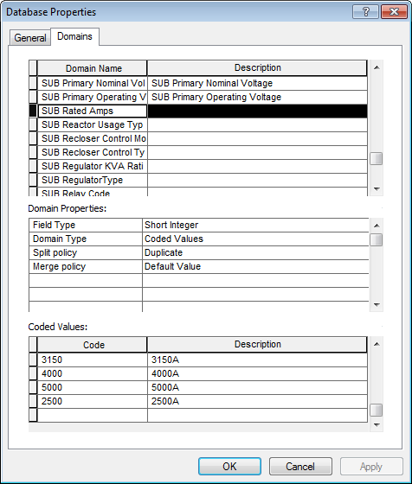
3. Select the Code column in the empty row and add the following value: 480/480A. Your screen should look like the following after the change is complete:  
   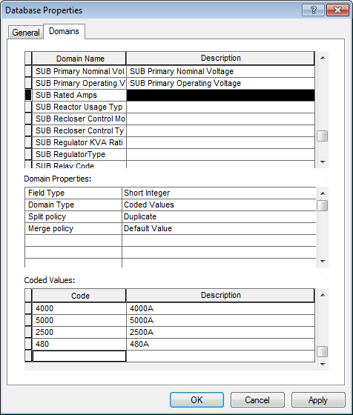
4. Select OK to save changes.

# Create New Feature Class SUBGenerator/SUBGeneratorAnno

1. Navigate into the SubstationDataset.
2. Create a folder connection to the path referenced in External Documents for the Personal Geodatabase.
   1. Right click the Folder Connections folder in the Catalog Tree and navigate to the path above.
   2. Select OK to create the connection.
3. Open the Personal Geodatabase in the Catalog Tree and expand it.  
   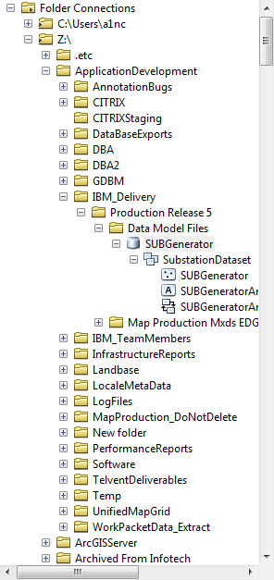
4. In the Personal Geodatabase: select all three objects under the SubstationDataset, right click, select Copy, right click the target SDE instance, and select Paste.  
   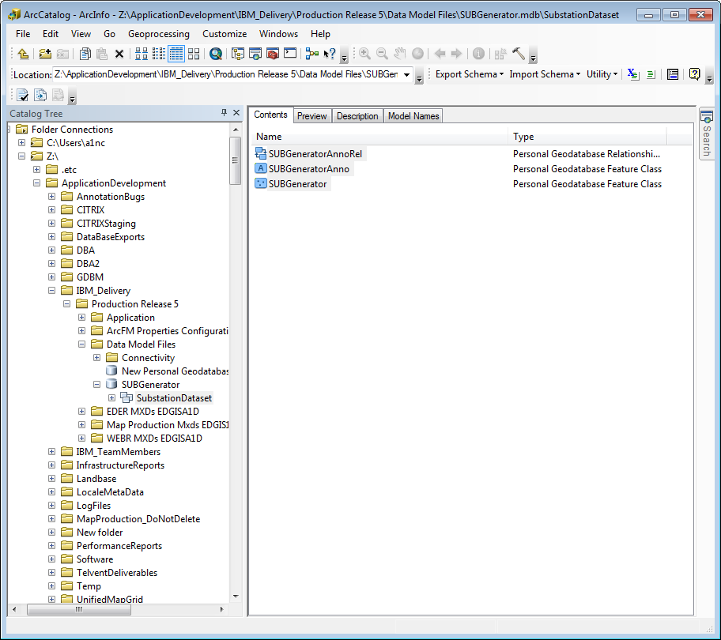
5. You will be prompted with a dialog confirming what you need to copy. Accept it:  
   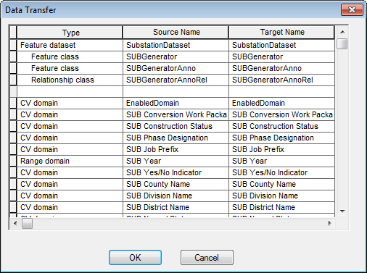
6. The feature classes and relationship will be copied into the target SDE instance.

# Add Additional Connectivity Rules

Import an XML configuration into the database to update connectivity rules

Before performing this step, please ensure that you have the connectivity rules patch (originating from Vinay) installed locally. Without this, performing this step will break the system.

1. Open the Geodatabase Designer toolbar in ArcCatalog.
2. Click the Output Window button on the toolbar to view the Output Window. 
3. Click the XML tab and click Open.  
   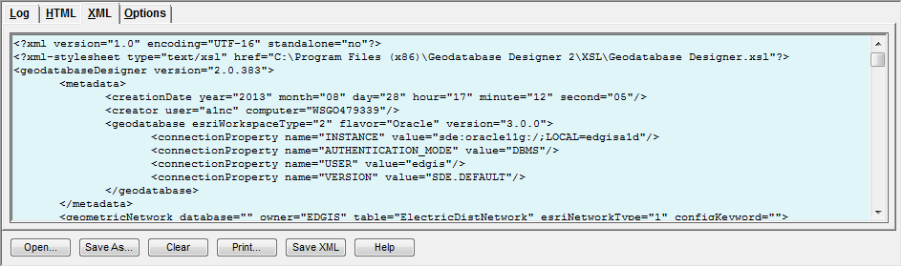
4. Copy/paste the filepath referenced in Section 1.3 of this document (titled External Documents) into the File Explorer window and select the Connectivity file in that folder (name referenced in Section 1.3 of this document).

1. Select the drop down on the toolbar of “Import Schema” ->Import From XML from the Designer toolbar to start the process. The streaming output will appear in the Log tab. When it displays some form of the following sentence, you are done:



# Update Data Model Version Table

**Database Configuration:**

1. Open SQL Plus.
2. Log in using the same server and user as was used in section 2.  
     
   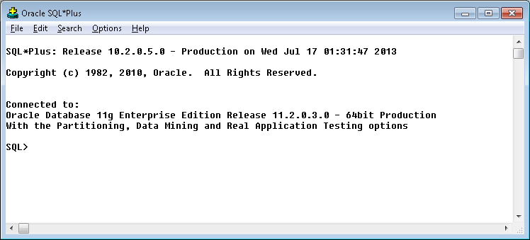
3. Run the SQL below:

update pgedatamodelversion set currentidc='N' where currentidc='Y';

insert into pgedatamodelversion (OBJECTID, CURRENTIDC, DATEAPPLIED, APPLIEDBYPERSONNAME, MODELVERSION) values (**37**,'Y',sysdate,'**<INSERT TEAM MEMBER DONE BY>**','**7.6.5** GOLD **CR9858**');

# Known Issues

<Please List any other issues encountered here while following the document>